**ReactJs** – ReactJs is a JavaScript library used for building user interfaces.

It is created/maintained by Facebook.

React is used to create single page application (if we want to add or update something on web page then we don’t need to change/render whole page, just add or update required section and it will work).

React working is based on reusable component. (For ex- suppose you created a component card. And you need to use it at many places in your project. So, you don’t need to create new card every time, just use that card component).

React work on virtual DOM (document object model). (if we change something in your project, firstly it will change in virtual DOM, then update it in real DOM).

Note- DOM stands for **'Document Object Model'.** It is a structured representation of HTML in the webpage or application. It represents the entire UI**(User Interface)** of the *web application as the tree data structure.*

It is a *structural representation of HTML elements* of a web application in simple words.

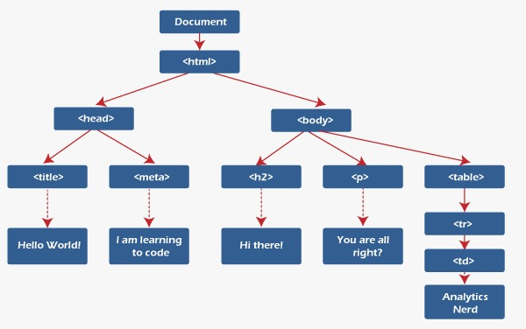

We work on react with HTML, CSS, JavaScript and NodeJs.

**NPX –** NPM stands for “Node Package Execute”.

**NPM –** NPM stands for “node package manager”.

Npm is the world's largest Software Registry. The registry contains over 800,000 code packages. Open-source developers use npm to share software.

**JSX** stands for JavaScript XML. JSX allows us to write HTML in React.

All **npm** packages are defined in files called **package.json**.

**npm** can manage **dependencies**.

**npm** can (in one command line) install all the dependencies of a project.

Dependencies are also defined in **package.json**.

**Few important commands-**

Command to create a react app in nodejs – “npx create-react-app app-name.”

npm start

Starts the development server.

npm run build

Bundles the app into static files for production.

npm test

Starts the test runner.

npm run eject

Removes this tool and copies build dependencies, configuration files

and scripts into the app directory. If you do this, you can’t go back!

cd project-name – to change directory to project name.

Ctrl+C – to terminate the program.

**Bootstrap -** **Bootstrap** is the **CSS Framework** for developing responsive and mobile-first websites. It contains predefined styles from CSS.

**Components inside the project –**

**Node modules –** It contains all dependencies of the project. (Like-react dependencies, reactstrap (it is bootstrap module for react) etc.)

**Public folder –** It contains🡪

favicon.ico (icon on title bar),

index.html file (main file which runs on webpage), (you can see <div id = “root”> in this file, which dynamically inject data from src folder).

manifest.json (specify basic metadata about your extension such as the name and version, and can also specify aspects of your extension's functionality),

Robot.txt (robots. txt file tells search engine crawlers which URLs the crawler can access on your site. This is used mainly to avoid overloading your site with requests).

**Src folder –** It contains actual javascript and css page on which we work, and from here javascript dynamically goes to index.html, which we see on webpage.

Src contain 🡪

Index.js – it is file which create root path by ReactDOM which goes in index.html, we pass our app inside this page.

And various other files, and files which we create.

**Reactstrap --** Reactstrap is a bootstrap-based React UI library that is used to make good-looking webpages with its seamless and easy-to-use component. Reactstrap does not embed its own style, but it depends upon the Bootstrap CSS framework for its styles and theme.

**Command to install reactstrap in project** 🡪 “npm install reactstrap” (we can’t run reactstrap without bootstrap, hence we need to install it too.).

Note- always remember all modules which we install, only install in project, not in system. For different project we need to install them once again.

You can see the dependencies in package.json file.

When you install any dependencies, you will see a command in terminal “npm fund” 🡪 it shows how to fund the dependencies of a given project to the developer.